Week 11 assignment Upper-Intermediate
- Study Grammar reference modals in the past (you can also find the picture uploaded as a separate file).
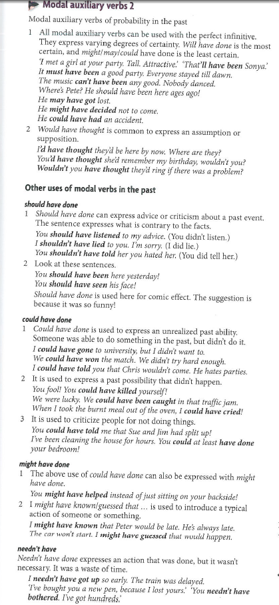
- Do grammar exercises (you can also find the picture uploaded as a separate file), write (type in Word) your sentences in full:
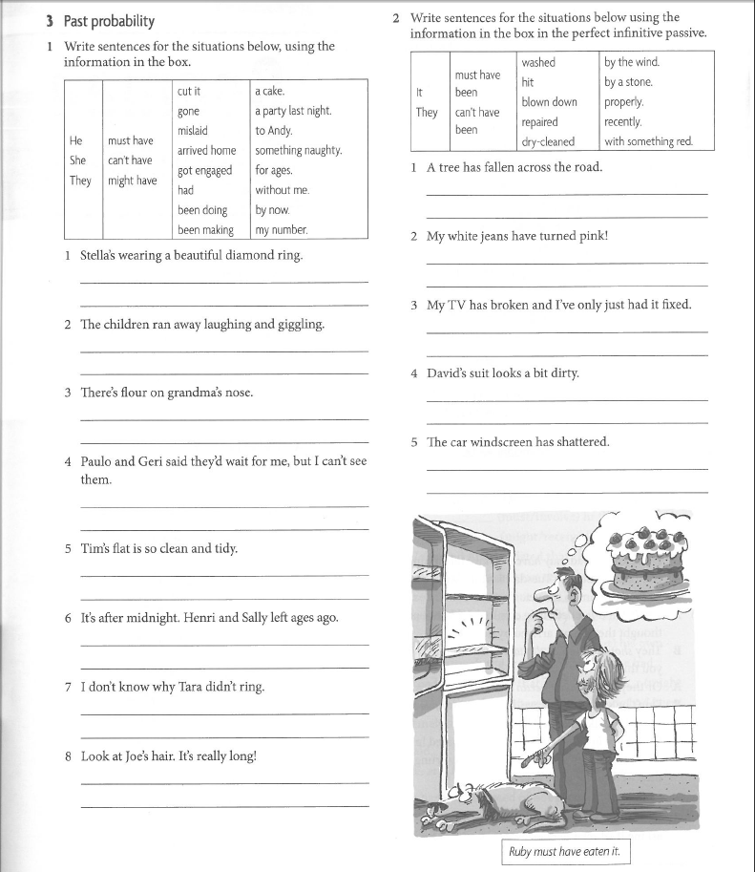

- Do exercises on extreme adjectives:
